Workplace Health and Safety Workbook

Contribute to Health and Safety of Self and Others
For this actively you will participate in two work activities that contribute to the health and safety of yourself and others.

- Maintain a clean work area and check for hazards
Game developers work with expensive computer equipment, which means it its important to keep our work area clean and clear of anything that could cause damage to our equipment – like open drink containers.
Garbage, foodscraps, and other debris can attract vermin which, in addition to being unhygienic, could result in additional damage to electrical cabling and components through chewed cabling or other damage.
Clean up your work area and do a visual inspection of the external components and cables of your equipment. Ensure powerboards and electrical outlets are not overloaded, and cabling does not present a trip hazard.
Take a photo of your work area using your phone or digital camera and insert it below.
If you identified any problems, make sure to inform your trainer or supervisor.

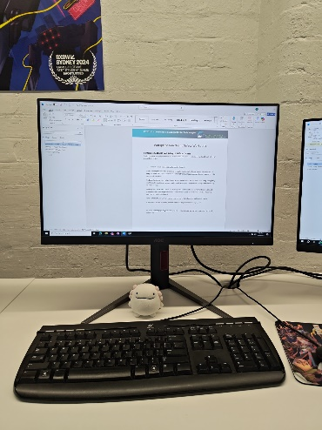
List any problems you identified here:
 | Problem or Hazard | Trainer/Supervisor  Informed | Date
1
2

- Complete a workplace safety audit
Identify at least 3 hazards in your workspace (in addition to the example). List each hazard in the table below.
Use the Risk Matrix below to measure the risk level of each hazard.
Hazard | Consequence | Likelihood | Risk Level
Cardboard Boxes in the way | Minor | Unlikely | Low
Tripping On Cables | Minor | Possible | Medium
Wet Slippery Floor | Moderate | Likely | High

IMPACT | LIKELIHOOD
 | Rare (1) | Unlikely (2) | Possible (3) | Likely (4) | Almost Certain (5)
Catastrophic (A) | M | M | H | C | C
Major (B) | L | M | M | H | C
Moderate (C) | L | M | M | M | H
Minor (D) | L | L | M | M | M
Insignificant (E) | VL | VL | L | L | M

Risk level | Required action
Critical | Act immediately:  The proposed task or process activity must not proceed. Steps must be taken to lower the risk level to as low as reasonably practicable using the hierarchy of risk controls.
High | Act today:  The proposed activity can only proceed, provided that:  (i) the risk level has been reduced to as low as reasonably practicable using the hierarchy of risk controls;  (ii) the risk controls must include those identified in legislation, Standards, Codes of Practice etc.  (iii) the risk assessment has been reviewed and approved by the Supervisor and  (iv) The supervisor must review and document the effectiveness of the implemented risk controls.
Medium | Act this week:  The proposed task or process can proceed, provided that:  (i) the risk level has been reduced to as low as reasonably practicable using the hierarchy of risk controls;  (ii) the risk assessment has been reviewed and approved by the Supervisor.
Low | Act this month:  Managed by local documented routine procedures which must include application of the hierarchy of controls.
Very Low | Keep a watching brief:  Although the risk level is low the situation should be monitored periodically to determine if the situation changes.

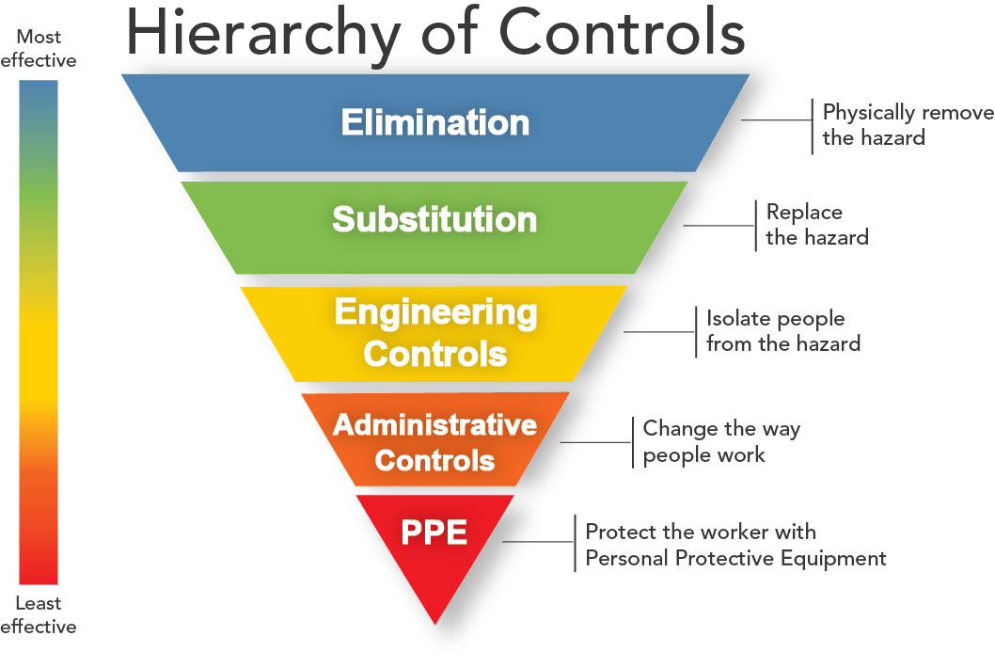
For each hazard you identified above, identify a method to control the risk of the hazard.
Try to use one of the more effective methods of control first. If that is not possible, use a less effective method.
Complete the table below, listing one or more control methods for each hazard you identified.
Hazard | Control Method
Wet floor | Put a wet floor sign
Cardboard Boxes blocking everyones way | Stack all those boxes and put them into a closet.

Identify and Report One Hazard
Most workplaces have a formal method for reporting a hazard or concern.
Using one of the hazards you identified in your workplace safety audit, complete the following workplace hazard report.
If you feel the hazard you identified poses an immediate risk to the safety of yourself and other learners, give this report to student administration or the local campus Head of School. Otherwise your trainer will follow up on any safety issues.

Hazard/Incident Report Form
Use this form in your workplace to report health and safety hazards and incidents.

Hazard/Incident
Brief description of hazard/incident: (Describe the task, equipment, tools and people involved. Use sketches, if necessary. Include any action taken to ensure the safety of those who may be
affected.)
15/04/2026 16:04 pm

Wet floors from the break room area someone was going to get their breakfast and unfortunately they slipped onto the ground
Where is the hazard located in the workplace?
The break room

When was the hazard identified? Yes / No | Date: 15/04/2026 | Time: 16:04 pm
Recommended action to fix hazard/incident: (List any suggestions you may have for reducing or eliminating the problem – for example re-design mechanical devices, update procedures, improve
training, maintenance work)
Staff has to put a wet floor sign to warn others theres a wet floor for safety until mopped.
Mopping the floor and let it dry or use something like a towel to absorb the water.

Date submitted to manager: | Date: 15/04/2026 | Time: 16:04 pm

Action taken
Has the hazard/incident been acknowledged by management? Yes/ No
Describe what has been done to resolve the hazard/incident:
The person should observe the place to find environmental hazard before they go in that area indicated by the sign.
The ground was mopped by a staff member

Do you consider the hazard/incident fixed? Yes / No
Name: Lachlan McElhinney | Position:Hallway
Signature:Lachlan McElhinney

Date:16/04/2026

Recognising the Signs
For each of the following signs that you might see around the workplace record next to each what it is referring to.
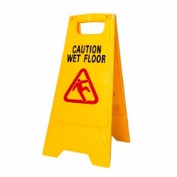 | Wet floor sign:Essential safety tools used to prevent slip-and-fall injuries by alerting individuals to slippery surfaces caused by cleaning, spills, or weather conditions. They serve as a critical component of occupational health and safety compliance, demonstrating a business’s duty of care.
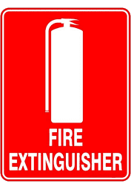 | Fire Extinguisher Sign:Active fire protection devices used to extinguish, or control small fires, often in emergency situations. They function by removing one or more elements.
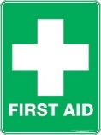 | First aid sign:Specialized emergency, information, and hazard-management symbols designed to be easily recognized, often adhering to international and local standards for safety in workplaces and public spaces.
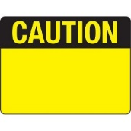 | Caution sign:Information regarding caution signs, particulary in Australian workplaces, is primarily sourced from AS 1319-1994 (Safety signs for the occupational environment), which outlines the design, color, and use of safety signs, These signs are designed to warn of hazards that are potentially harmful but generally not life-threatening.

Fire Safety
Head to the following link and answer the following questions, it goes to a page describing the 10 measures to increasing Fire Safety.
https://www.amsj.com.au/fire-safety-measures-workplace/
List each of the measures and in your own words, briefly describe each one
Employees risk
“It depends on which workplace you’re at to be exposed of fire hazards more frequently
Fire hazards.”
“Any dust or technology that’s plugged into a plug outlet not properly or putting 2 fires adjacent to each other is a fire hazard.”

How often do fire extiguishers require internal maintenance?
For every 5 years fire extiguishers will be inspected by technicians.

Now head to this final link: https://www.fire.nsw.gov.au/page.php?id=74
In your own words describe what to do in the event of a fire based on the RACE acronym
Rescue as many people as possible,
must raise alarms for emergency evacuation must contain the fire by close all windows and doors or any entrance to outside to contain the fire if safe to do so and extinguish the fire with the fire extinquisher.

